The Physical Geography of My Community

Student’s Name
Department, University
Course Number and Name
Instructor’s Name
Date

Table of Contents
Introduction 3
Part I 4
Air pollution 4
Scattering 4
Localized Wind Systems 5
Midlatitude Cyclone 6
Anthropogenic Climate Change: mitigation and adaptation 7
Part II 8
Terrestrial Flora and Fauna: Mediterranean Woodland and Scrub 8
Sedimentary rock feature 8
Biological Weathering 9
Mass wasting (landslide) 10
Human Alteration of Coastal Sediment Budget 11
Lithosphere (ocean trenches) 12
Conclusion 12

The Physical Geography of My Community

Introduction
Physical geography is one of the two major branches of geography. It deals with natural processes that occurs on the natural environment. Different processes and patterns occur in our surrounding physical environment every day. Learning geography helps in identifying the natural processes and knowing how to handle the effects. Hydrology and Geomorphology are branches or physical geography that include major processes that occur frequently, with or without people’s knowledge. For example, Hydrology involves the movement and accumulation of water on the earth’s surface and underground. People should understand the water movement processes because human beings rely on water for survival. Physical geographical activities occur differently in different parts of the world depending on the location and human activities.

Part I

Air pollution
Air pollution is a common geographical phenomenon that mostly occurs in populated geographical locations. In the nineteenth century, air pollution was not a common issue because there were few industries across the world. In the recent years, there have been rapid industrial and population growth of urban and rural areas. When gases and fumes wastes are released in the air uncontrollably, they cause air pollution. Focusing on Orange County, it is one of the most advanced areas in California. The rate of air pollution has been increasing in the County due to the growing population and wild fires that occur during drought seasons.
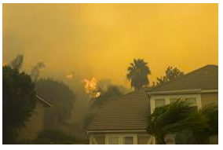
This image shows a section of Orange County covered with heavy smoke and ash. Increased human population has led to high industrialization which results to air pollution. Orange County has recently joined the many Counties that require urgent measures to curb the issue of air pollution.

Scattering
Scattering is a process under physical geography where the amount of solar radiation is reduced. The process happens when some particles diffuse solar radiations without affecting the wavelength of the electromagnetic energy. Gas molecules also diffuse the radiations and prevent them from reaching the earth’s surface. After scattering, some shortwaves are redirected to the space. There are two major factors that determine the scattering process. One of the factors is the amount and size of particles or gas molecules in the atmosphere. The second factor is the wavelength. When there are large amounts of particles in the atmosphere cause the scattering of shorter wavelengths. Scattering causes the sky to appear blue. If scattering does not occur, then the sky would appear black. According to ("404," 2020), in Orange County, gases and particles are majorly released to the atmosphere during cremation services.
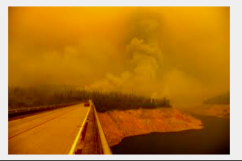
The above image shows the orange sky in Orange County. The orange color results from scattering process. When gasses and smoke is released in the atmosphere, it blocks the radiations from reaching the earth, which interferes with the tint of the sky.

Localized Wind Systems
The heating and cooling cycles that occur daily in our environment causes the occurrence of local wind systems. The wind blows due to the changes in the atmospheric pressure. According to the knowledge learned in physical geography, air flows from areas with high pressure to those with low pressure. The earth’s surface plays a crucial role in heating the air above it. When air is heated through convention and conduction, it raises, causing sudden or slow winds. Different geographic locations experience localized wind systems depending on factors like proximity to the sea of vegetation. For example, some cities in Orange County are likely to experience breezes due to high proximity to the sea. Such cities include San Clemente and Dana Point.
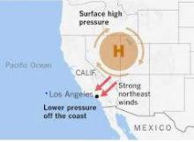
The photo shows a section of the famous Santa Ana winds. The area experiences strong northern winds as air moves due to the difference in air pressure in the coastal region.

Midlatitude Cyclone
These are cyclonic flows that occur in middle latitude areas. They are cyclonic storms that travel in form of storms in large areas. They occur in low pressure systems due to the interaction of warm and cold air masses. The cyclones produce different types of precipitation that include rain, snow and hail. Most of the frozen precipitation is common in winter months. However, hail is mostly experienced in spring and summer seasons because it occurs in cold fronts, causing severe thunderstorms.
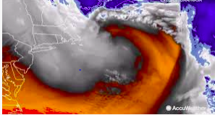
This image shows an example of mid latitude Cyclone in Orange County. The center of the storm can be observed in the lake region. The wave is at its mature stage which cause heavy storms in the region. Such a cyclone results from interaction of warm, moist and cold air. The storm travelled hundreds of kilometers, causing effects to the natural and artificial features on the ground.

Anthropogenic Climate Change: mitigation and adaptation
Anthropogenic Climate Change involves the analysis of how human beings contribute to the larger percentage of the causes of climatic changes. Burning coal is one of the leading human activity that lead to climatic changes. Releasing the gases to the atmosphere does not cause instant climatic changes. Continuous emission of harmful gases and particles in the air causes effects after many years later. Scholars have been introducing many theories to explain the processes that take place in the physical environment. Orange County is one of the areas with many human activities that lead to climatic changes.
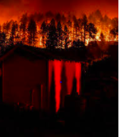
This image shows wildfires that occurs in Orange County frequently. According to various reports, humans are sometimes responsible for the frequent fires in the wild. Following the existing processes of gas emission to the atmosphere, people have two options to regulate climatic changes. The two strategies include the reduction of emissions and stabilizing the greenhouse gases to the air.

Part II

Terrestrial Flora and Fauna: Mediterranean Woodland and Scrub
In physical geography, terrestrial flora and fauna involves the natural vegetation and creatures that exist on the earth’s surface. It is the community of organisms that affect the natural features and climate of the earth. Mediterranean Woodland and Scrub are the examples of the terrestrial system. The type of terrestrial ecosystem in different geographical areas depends the temperature of the area, type of soil, the amount of precipitation and light received in the area. For example, areas near the beach in the Orange County may have different terrestrial system from other areas that are far from the coastal region.
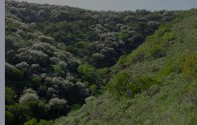
This picture shows a section of the coastal region of the Orange County. The photo was taken a while ago, but it shows the real terrestrial system in the coast of the Orange County. The vegetation is the sage scrubs that grow along the coastal region of the County. The warm climate in the region supports the growth of scattered scrubs.

Sedimentary rock feature
According to physical geography, sedimentary rocks form as a result of weathering of rock debris in the process of lithification. The rock debris are then transported across the earth surface to different locations. In the process of transportation, the small rocks are rolled against the surface and form rounded debris. Sandstones are examples of the sedimentary rocks. However, some forms of sedimentary rocks are formed from chemical precipitation. In Orange County, there are various features that developed from sedimentary rocks. Vaqueros is one of the known feature in California. Sespe formation is also a famous feature that resulted from the sedimentary rocks.
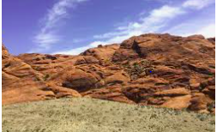
This picture shows images of sedimentary rock feature in the Orange County. The rocks are clear and it is easy to tell the sizes and shapes. The rocks are mostly round in shape because they become shaped as they move against the earth’s surface. Heavy sedimentary rocks can remain on the ground over a long time.

Biological Weathering
In physical geography, biological weathering is caused by plants and animals. Plants and animals are known to release some acidic chemicals that cause breaking of rocks and natural landforms. Biological weathering can be physical or chemical. Physical involves the breaking of rocks as a result of physical activities by the living organisms and plants. For example, as trees grow, the roots penetrate in the ground and cause the breaking of rocks and the surface to crack. Even the tiniest organisms like bacteria can cause changes in the texture of the rocks and surfaces as they penetrate. Chemical weathering is caused by the reaction of the acidic waste released by plants and animals. For example, animals release acidic content from their bodies through waste (Finlay et al., 2019). When human and animal waste remain on the ground for some time, the acid reacts with the rocks to cause breakage.
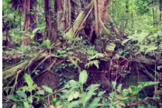
This picture was taken in an area in Orange County, where biological weathering occurred due to the growing roots of vegetation.

Mass wasting (landslide)
Mass wasting involves the process of movement of soil, sand or rocks from a high area to low lying areas. The downslope movement can cause erosion as the material sometimes moves under pressure, sweeping away the materials on the surface. In the past years, such processes were caused by natural forces like rain or strong winds. In the recent years, humans have been contributing highly to the downslope movement of material debris due to poor farming methods and constructions. Landslides are a major types of mass wasting. Landslides can be defined as movement of heavy rocks or debris downslopes. They occur under the influence of gravity, because they cause the material to move on the earth surface (Handwerger et al., 2019, p1782). The picture below demonstrates an example of mass wasting in the Orange County.
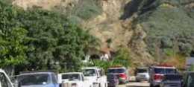
The picture captured the result of a landslide that occurred in 2005, in Blue Bird Canyon. The landslide occurred near a major road, where rocks moved from a high area to the low area, causing disruptions.

Human Alteration of Coastal Sediment Budget
Humans affect the coastal sedimentary budget through nourishment of the beach. Sediment equilibrium can be maintained by beach nourishment. Human activities done along the coastal areas are the major causes of the alteration of the nature of the beaches and other features in the coastal regions. Research shows that the altered sediments can be restored through replacement activities. One of the successful ways that countries across the world have adapted is the transportation of sediments to the beaches. For example, people can load sediments in Lorries and dump them at the beaches. Machines are then used to spread the materials along the areas to replace the altered sediments.
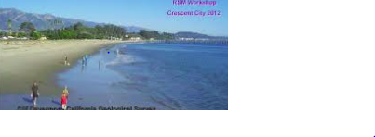
The picture above is an example of the management plan in the Orange County in California. The coastal region sediment budget plan aims at restoring the altered material to maintain the appearance and nature of the beach.

Lithosphere (ocean trenches)
Lithosphere is part of physical geography that involves the study of the movement of the earth crust which are referred to tectonics. In Orange County, the movement of the earth’s crust affects the ocean because it cause ocean trenches. Though the tectonic activities are rare in the ocean, they can occur at any time when the earth surface moves. Ocean trenches are narrow depressions that cut across the sea. They form the deepest parts of the ocean. San Andreas fault is an example of a tectonic in Southern California. Below is a picture of another tectonic fault in the ocean, which was named Marianas Trench

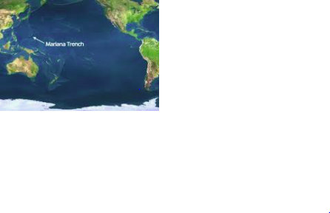

Conclusion
Learning physical geography is helpful because individuals can easily identify natural activities and know their causes. After analyzing Orange County, it is clear that California is rich in geographical formations that are mostly associated with the beaches and oceans. Different earth’s locations have various natural geographical activities that occur on a daily basis. Humans should take charge in managing the environment to reduce the occurrence of destructive activities.

References
404. (2020, September 11). Spectrum News | Bay News 9. https://www.baynews9.com/fl/tampa/weather/2020/09/11/why-is-the-sky-in-califo
Finlay, R. D., Mahmood, S., Rosenstock, N., Bolou-Bi, E. B., Köhler, S. J., Fahad, Z., ... & Lian, B. (2019). Biological weathering and its consequences at different spatial levels–from nanoscale to global scale. Biogeosciences Discuss, 10.
Handwerger, A. L., Fielding, E. J., Huang, M. H., Bennett, G. L., Liang, C., & Schulz, W. H. (2019). Widespread initiation, reactivation, and acceleration of landslides in the northern California Coast Ranges due to extreme rainfall. Journal of Geophysical Research: Earth Surface, 124(7), pp1782-1797.

